Issue | Tilt Complaint
Camera | NDE-xxxx-AL
Description | Rework Instructions
Report

Disassemble IR ASSY (IR LED + IR Holder): 3x M2x6 torx screw.
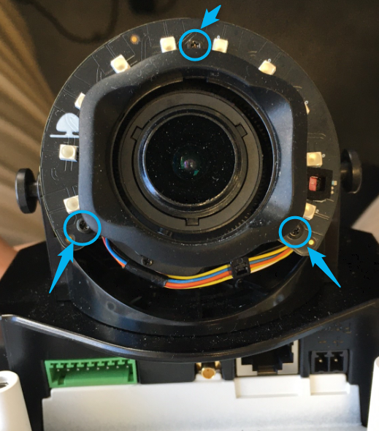

Loosen the 2x side screws holding the lens: 2x M2 hex screw.
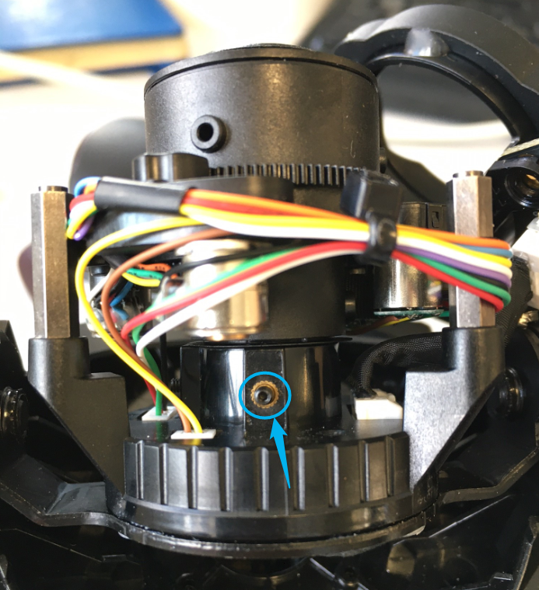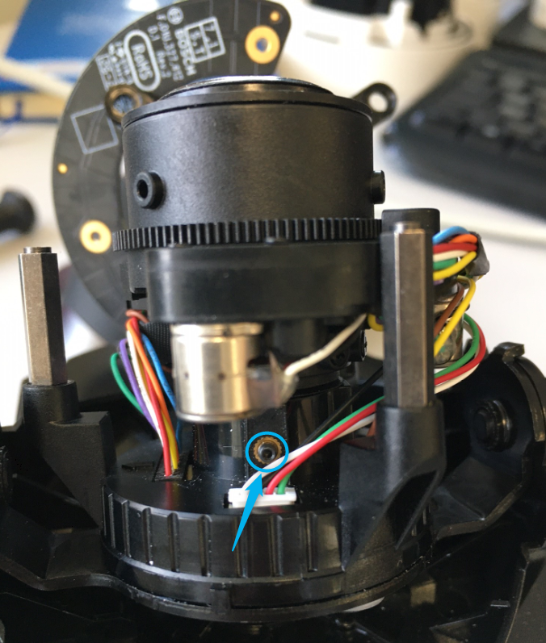

Pull slightly the lens (do not pull it out completely) and push it back.
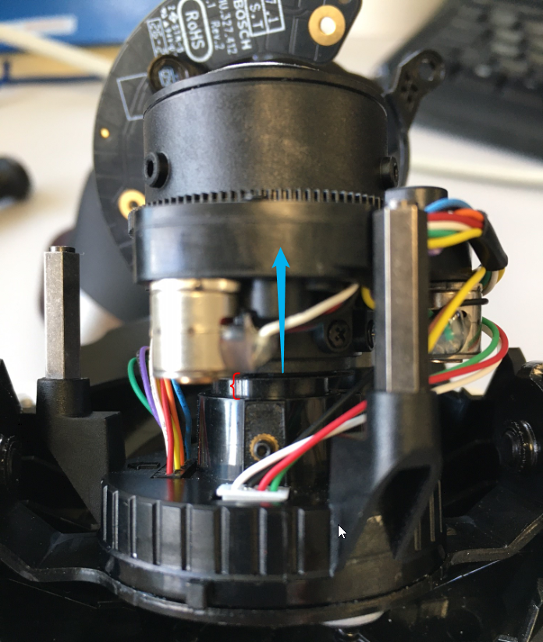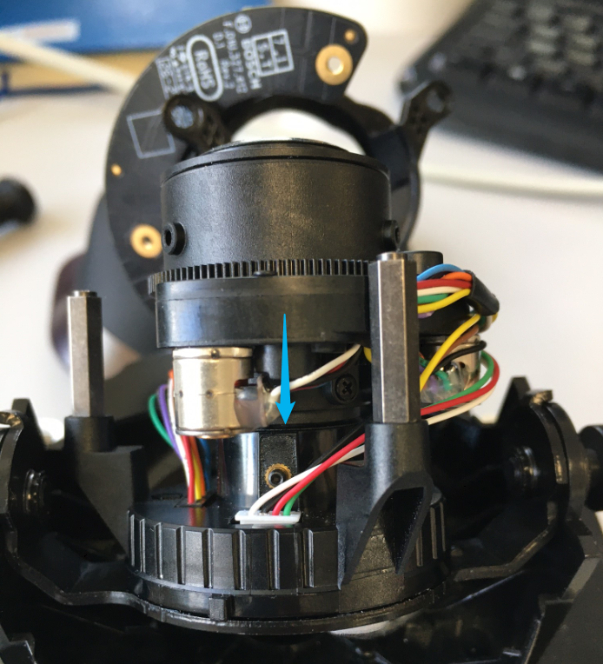

Tighten the 2x side screws holding the lens: 2x M2 hex screw, 0,025Nm torque

Re-assemble the IR ASSY (IR les + IR Holder): 3x M2x6 torx screw, 0,1Nm torque

BT-VS/PMO1

